# React Forms:

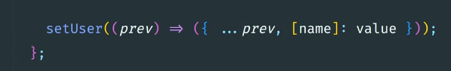

[name] is dynamic variable